
QUALITY ALERT

Customer: Panes Date: Mar 7, 2025
Die: 15157 Colour: Any colour
Type of Complaint: Customer REJECTED

Q.A # Q.I.R # CUSTOMER NCR #

Description: Panes REJECTED due to fin hole is too small, can’t slide fin in.

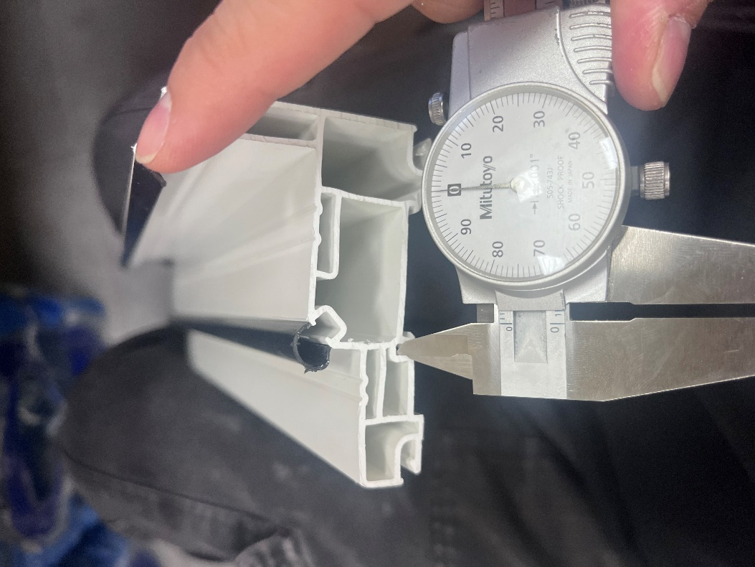
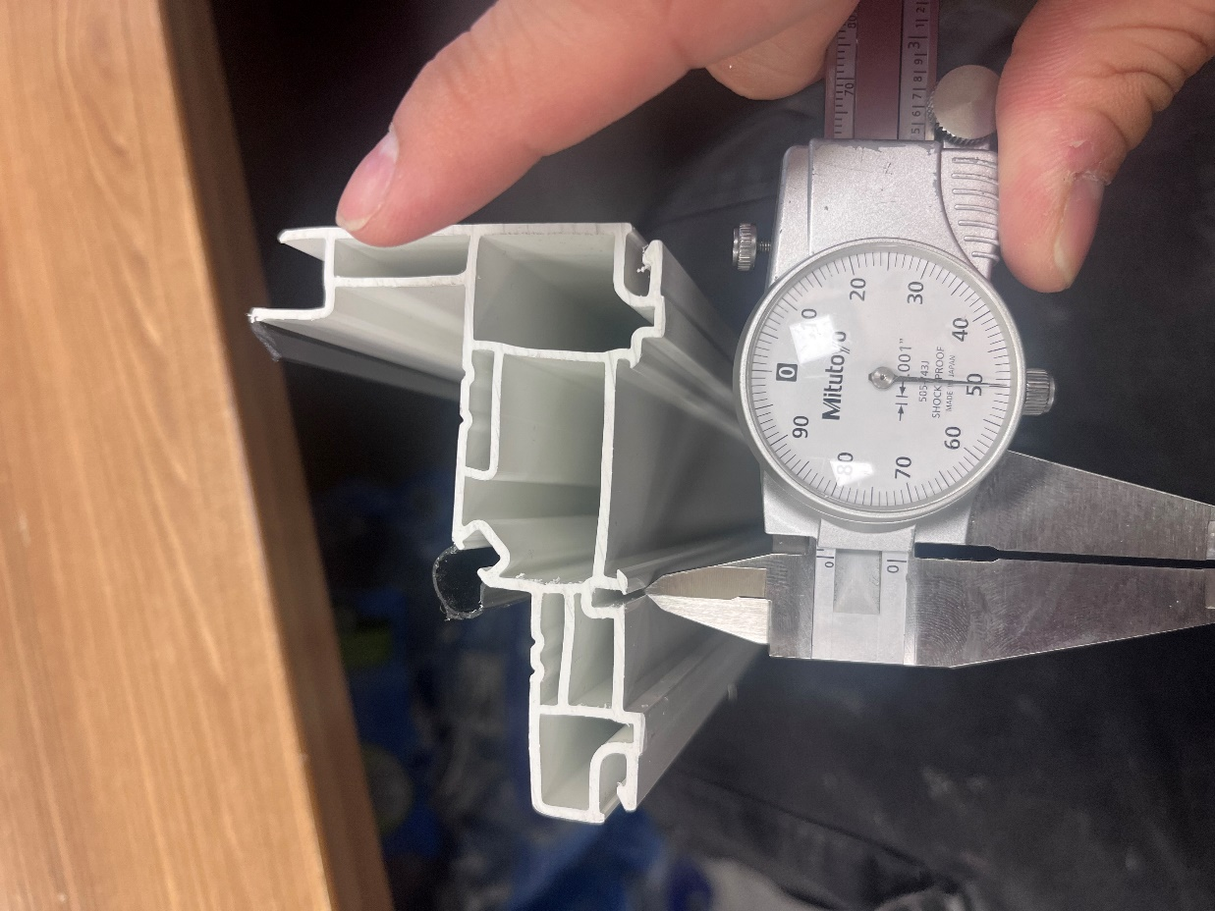

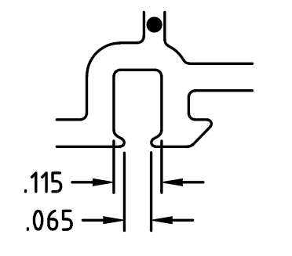

PLEASE CHECK MAKE SURE FIN GOES IN SMOOTHLY

BY SIGNING BELOW, YOU ACKNOWLEDGE THE PROBLEM ABOVE AND AGREE TO MONITOR THIS ISSUE IN FUTURE PRODUCTION RUNS.
DAY SHIFT |  | AFTERNOON SHIFT |  | NIGHT SHIFT
NAME | SIGNATURE | NAME | SIGNATURE | NAME | SIGNATURE

